BAOMS Travel Grant 2020-2021

Richard Cobb FRCS(OMFS)

Destination: Royal Melbourne Hospital, Victoria, Australia
Duration: 12mths
Sub-specialty: Facial Deformity & Facial Trauma

I undertook a fellowship at the Royal Melbourne Hospital in the Australian state of Victoria. This position is supported by the Head of Unit A/Prof Alf Nastri. Alongside him there are several other consultants including Prof David Wiesenfeld, A/Prof Steven Gibbons, Mr Tim Wong, Mr Ricky Kumar, Mr Felix Sim, Mr Jameel Kaderbhai, Mr Joe Gunn and Ms Nu Dastaran.

The Royal Melbourne Hospital is one of Australia’s leading public hospitals and was first established in 1848. It is affiliated with the University of Melbourne and is a major teaching hospital for tertiary health care for the state of Victoria. It functions as one of two major trauma centres within the city, accepting severely injured patients via the air ambulance service from across the state.

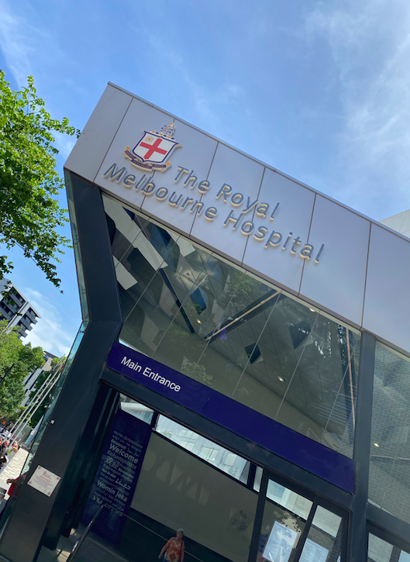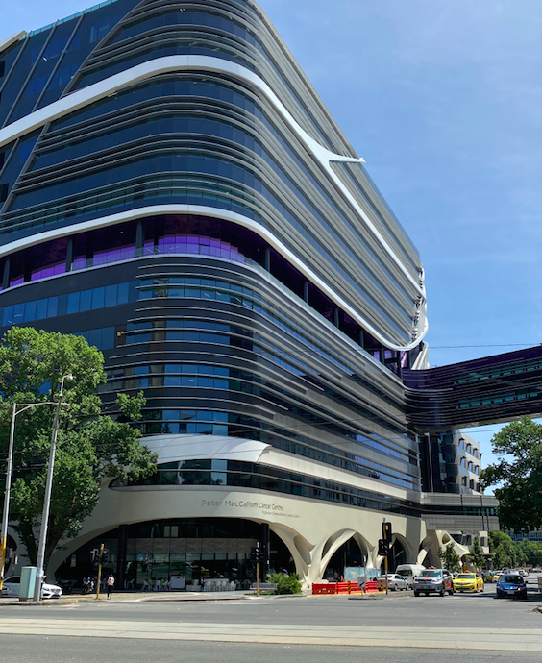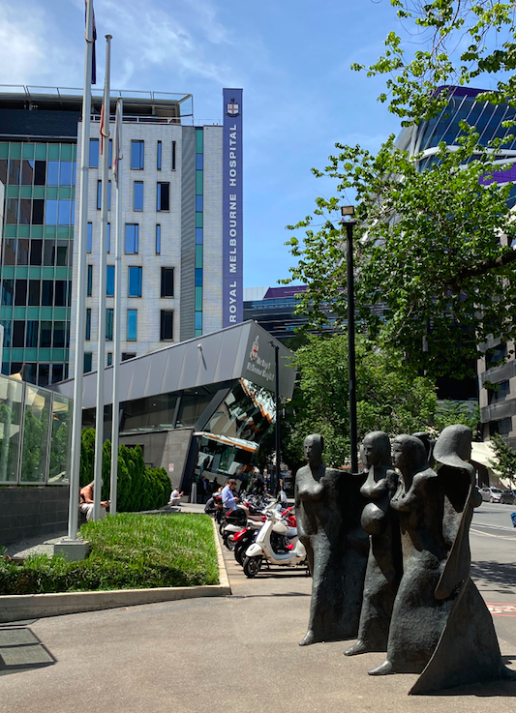
Fig. 1. The Royal Melbourne Hospital and the Peter Mac Cancer Centre

The population of Victoria is 6.9million, spread over an area roughly the size of the UK (approx. 240,000km²). It is the most densely populated state in Australia.

The full remit of OMFS is practiced within the unit, including H&N services, orthognathic, cranio-facial trauma, TMJ surgery & replacement, salivary gland surgery and dental implantology. Currently, H&N reconstruction is provided by plastic surgery with a good working relationship between the two specialties.

There is excellent onsite access to a maxillofacial laboratory with close relationships with techincians. Additionally, there is comprehensive use of VSP and 3D printing for H&N cases/reconstruction (both benign and malignant disease), orthognathics, TMJ and facial trauma.
The OMFS unit runs with a full time medically qualified resident (SHO) from the basic general surgical training programme and two accredited OMFS training registrars (usually one junior, and one senior). In addition to the Head of Unit, there are nine consultants who all contribute to the oncall service (undertaking ‘hot’ weeks) and who each have varying numbers of elective operating lists.

Four consultants have an interest in H&N oncology, one has an interest in TMJ surgery and the rest undertake the general scope of OMFS practice with a focus on facial deformity/facial trauma. The unit undertakes H&N operating on a Tuesday and Wednesday and OMFS operating on a Monday, Thursday and a Friday. There are registrar clinics on a Monday, orthognathic clinics on a Tuesday and a consultant clinic on a Wednesday (a multi-consultant clinic). There is good prosthodontic support with part time prosthodontists and good relationships with the nearby Royal Melbourne Dental School (RMDH). Interestingly, the orthognathic referrals come from specialist orthodontic practices from across Melbourne and the RMDH, with no in-house orthodontics. Despite this there are a large number of orthognathic cases undertaken within the department.

There is a separate OMFS unit at the Royal Childrens Hospital which is half a kilometer away from the RMH. Here, secondary cleft, paediatric facial trauma, distraction osteogenesis and cleft orthognathics is undertaken. The cranial and primary cleft work is undertaken by PRS. The OMFS unit is led by Prof Heggie and Prof Shand who were both extremely welcoming to me, despite there being a dedicated Royal Children’s OMFS Fellow position. They have particular experience and expertise in infant mandibular distraction for upper airway obstruction.

During my time in Melbourne there was a cadaveric dissection course on the management of complex cranio-maxillofacial trauma on which I was invited as faculty. It involved utilising pre-fractured cadavers and pre-operative CT imaging, which was a first for Australia. The quality of the course was excellent with a comprehensive OMFS faculty. It was very well attended with multi-disciplinary delegates from across Australia/New Zealand.

Fellowship Activity:

The RMH fellow works closely with A/Prof Alf Nastri who is a charismatic individual and who takes a huge amount of time for mentoring, with lessons covering everything from the nuances of maxillofacial surgery to Italian cooking! He is fond of the UK, having spent time training in Southampton with the late Barrie Evans. His scope of practice mainly involves orthognathic surgery, facial trauma and post-traumatic deformity and he undertakes around 250 orthognathic cases a year.

As the fellow I undertook supervised responsibility for the orthognathic assessment and treatment planning of all patients. Additionally, I performed the model surgery and splint fabrication. This was particularly useful for me coming from a region where much of this is undertaken by maxillofacial technicians. It gave me an excellent appreciation for the 3-dimensional aspects involved when planning the surgery and provided the focused time to really consider the skeletal and soft tissue changes associated with planned movements. Additionally, I was operating on all orthognathic cases and supervising registrars.

Over the course of my time, orthognathic practice in Australia moved away from model surgery to VSP (3D printed wafers, cutting guides and maxillary plates) -for cases involving maxillary surgery. There were plentiful opportunities to plan these cases using a number of different companies. Additionally, there was experience gained in joint TMJ/orthognathic surgery.

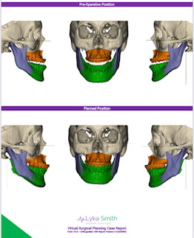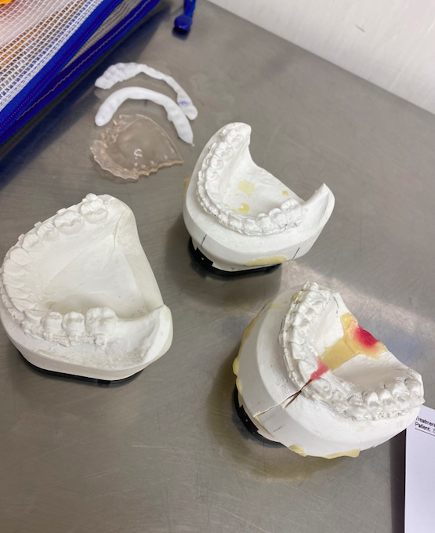
Fig. 2. VSP planned Bimaxillary Surgery vs. convential model surgery/wafers

As a Level 1 trauma center, a significant proportion of the public hospital workload involved facial trauma. I was able to gain experience managing complex injuries including pan-facial trauma. Additionally, there were good working relationships with neurosurgery for the management of craniofacial injuries. There was excellent lab/VSP support for things as palatal splints for injuries involving palatal fractures.

There was a weekly multi-disciplinary facial trauma meeting in which all pre and post-op cases are discussed with imaging. This was an excellent educational opportunity and allowed discussion and cross-pollination of ideas from multiple specialties.

There was a sizeable surgical TMJ workload. I was able to gain further experience in TMJ arthroplasty (eminectomy, discectomy, partial condylectomy, and interpositional grafts) as well as total joint replacement. Interesting pathology that I had not been exposed to before included PVNS (pigmented villo-nodular synovitis), as well as a TMJ chondrosarcoma.

The joint replacements were mainly Zimmer Biomet custom design, however there was a move during the fellowship toward a joint that I hadn’t used in the UK called OrthoTin. This is a US made custom TMJ replacement. The joint has a condylar component made from titanium with a titanium nitride coating. The fossa component is made from solid milled titanium alloy, with an emergence flange and ultra high molecular weight polyethylene bearing which is inserted to replace the fossa and articulate with the prosthetic condylar head. The design is similar to TMJ Concepts, however with a different manufacturing process.

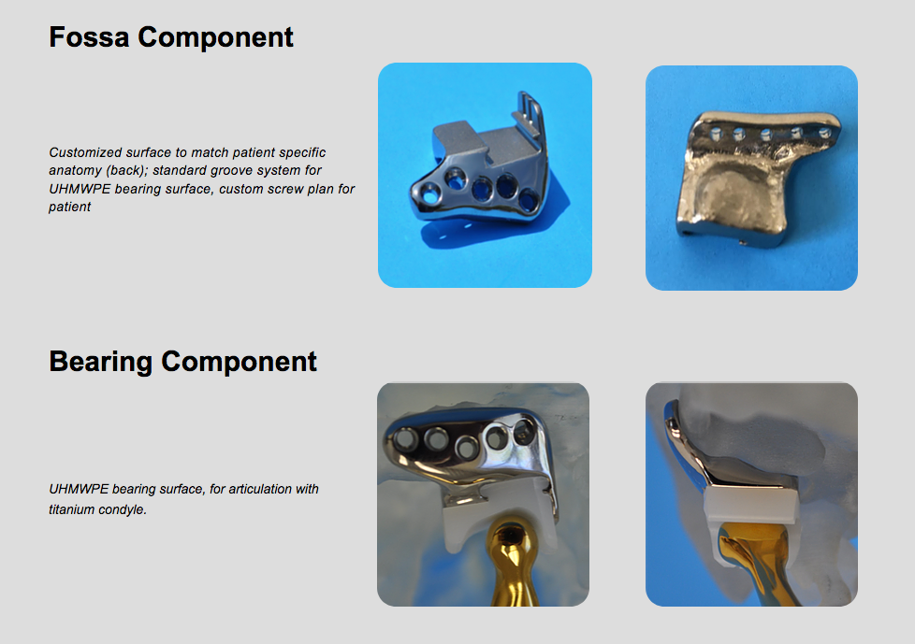
Fig. 3. OrthoTin TMJ replacement, fossa component

I have an interest in facial aesthetic surgery and whilst in Melbourne I spent time with Dr. Bryan Mendelson. His MAFAC aesthetic facial anatomy course was unfortunately cancelled this year due to COVID, however I was fortunate to spend time with him gaining additional exposure to blepharoplasty, brow lift, facelift, skeletal augmentation and fat transfer. I am very grateful to him for giving me his time and for sharing his thoughts and concepts on facial anatomy and aesthetic techniques.

COVID-19:

It was unfortunate that not long after I landed in Australia the world was hit by this viral pandemic. Australia & New Zealand were fortunately relatively protected from the worst of the pressures on healthcare services, however there were still significant lockdowns and cancellation of elective services in Melbourne. I was lucky in that once elective services were re-started there was eagerness and encouragement to ‘catch-up’ on the delayed elective work so that by the end of my year my logbook figures were appropriate for the time period.

OMFS in Australia:

As well as surgical experience, the fellowship was an opportunity to experience healthcare provision in a geographically challenging region. Acute OMFS patients were being transferred to us from extremely rural environments with relatively poor medical infrastructure. Identifying time critical patients and arranging safe/appropriate transfers was difficult. Additionally, ensuring adequate follow up for patients when they are living 3-4 hours away also adds complexity.

My time in Australia confirmed how well developed and accepted our specialty is in the UK. Also, how fortunate we are with our access to multi-disciplinary planning and working. Australian OMFS has a variable scope of practice across the country and is still evolving its role in H&N, reconstruction and cleft. There are, however, many exceptional individuals broadening the scope of the specialty there.

Acknowledgements:

I am particularly grateful to two of the Royal Melbourne registrars: Richard Huggins and Chris Singleton for helping me to acclimatize to the Australian way. To A/Prof Alf Nastri for having endless patience with my questions and for his pragmatic approach to problem solving. Additionally, to all the consultants at the Royal Melbourne who all have taught me, in particular to Mr Ricky Kumar for his thoughts and surgical teaching on complex orthognathics, TMJ surgery and surgical approaches to the infratemporal fossa. Finally, to the administrators: Alice Bolzonello and Sunita Sharma who were instrumental in guiding me through the red-tape.

I would very much recommend this fellowship to anyone interested in maxillofacial trauma & deformity/TMJ surgery, and anyone who wants to experience the evolution of OMFS in the southern hemisphere.

I am most grateful for the support and generosity of BAOMS to support this experience which has significantly complemented my UK training.

